A
MINI PROJECT REPORT ON
Online Food Order Processing System Using Queue Data Structure

SUBMITTED TO SAVITRIBAI PHULE PUNE UNIVERSITY, PUNE
IN PARTIAL FULFILLMENT OF THE REQUIREMENTS FOR THE AWARD OF DEGREE OF

BACHELOR OF TECHNOLOGY (B.TECH)
(Artificial Intelligence & Machine Learning)
BY

Prajakta Dharekar 32121
Sonali Gupta 32129
Ashlesha Wankhade 32110
.

Under The Guidance Of
Ms. Sneha Bankar



Department of Artificial Intelligence - Data Science and Machine Learning

Dr. D.Y. Patil College of Engineering & Innovation Varale – Talegaon, Pune – 410507

SAVITRIBAI PHULE PUNE UNIVERSITY, PUNE

Academic Year: 2026 – 2027

Department of Artificial Intelligence - Data Science and Machine Learning

CERTIFICATE

This is to certify that the Mini Project entitled

Online Food Order Processing System Using Queue Data Structure

Prajakta Dharekar 32121
Sonali Gupta 32129

Ashlesha Wankhade 32110

is a bonafide work carried out by them under the guidance of Ms. Sneha Bankar, in partial fulfillment of the requirements of Savitribai Phule Pune University, Pune for the award of the degree of Bachelor of Technology in Artificial Intelligence and Data Science.

Ms. Sneha Bankar Dr. Dipannita Mondal Guide Head- AI- DS & ML

Dr. Suresh Mali Director

Signature of Internal Examiner Signature of External Examiner

ACKNOWLEDGENT

It is our pleasure to acknowledge sense of gratitude to all those who helped us in completion of Mini project. I am highly indebted to Ms. Sneha Bankar for their guidance and constant supervision as well as for providing necessary information regarding the internship & also for their support. I would like to express my gratitude towards Head of Artificial Intelligence - Data Science and Machine Learning Department Dr. Dipannita Mondal for their kind co-operation and encouragement which help me for providing the required facilities. Finally, we wish to thank and appreciate to all our teachers and friends for their constructive comments, suggestions and guidance and all those directly or indirectly helped us in completing this Mini Project.

Prajakta Dharekar
Sonali Gupta
Ashlesha Wankhade

Place: Pune

Date:
16-10-2026
Contents

1 | Chapter 1: Introduction | 5
2 | Chapter 2: Problem Statement | 6
3 | Chapter 3: Objectives | 7
4 | Chapter 4: Motivation | 8
5 | Chapter 5: Scope and Rationale of the Project | 10
6 | Chapter 6: Methodological Details | 11
7 | Chapter 7: Results | 13
8 | Chapter 8: Analysis | 16
9 | Chapter 9: Inferences | 17
10 | Chapter 10: Conclusion | 18
11 | Chapter 11: Suggestions | 19
12 | Chapter 12: Acknowledgments | 20
13 | Chapter 13: List of References | 21

Chapter 1: Introduction

The Online Food Order Processing System Using Queue Data Structure is a web-based application designed to simplify and manage the food ordering process. It allows customers to view the food menu, select their favourite dishes, add items to the cart, and place orders online.
The system uses the Queue Data Structure, which follows the FIFO (First In, First Out) principle. This means that the order placed first is processed first. It helps maintain the correct sequence of orders and makes order management more organized.
The website is developed using HTML, CSS, and JavaScript for the frontend, Python Flask for backend operations, and SQLite for storing order details. The system also provides an admin dashboard to manage orders and update their status, such as Pending, Preparing, and Completed.
The main purpose of this project is to demonstrate the practical use of queue data structures in a real-world application while providing a simple, efficient, and user-friendly food ordering system.

Chapter 2: Problem Statement

Despite the increasing use of online food ordering systems, managing multiple food orders efficiently remains a challenge:
- Order Management: Difficulty in maintaining the correct sequence of incoming food orders.
- Processing Delays: Poor coordination in preparing and completing orders during busy hours.
- Manual Errors: Incorrect order handling and confusion between pending and completed orders.
- Lack of Tracking: Customers may find it difficult to know the current status of their orders.
This project aims to:
- Develop a functional online food ordering website with a customer interface and an admin dashboard.
- Implement the Queue Data Structure using the FIFO (First In, First Out) principle to process orders in sequence.
- Provide order status tracking, including Pending, Preparing, and Completed.
- Simplify order management and improve the efficiency of food order processing.
Industry-Specific Challenges
- Restaurants: During peak hours, a large number of orders can create difficulties in maintaining the correct processing sequence.
- Customer Experience: Delays and a lack of order-status updates can reduce customer satisfaction.
- Operational Efficiency: Manual order management may lead to confusion, processing errors, and delays.
- Technical Challenges: Maintaining an accurate queue and updating order statuses consistently are important for reliable order processing.

Chapter 3: Objectives

1. Develop an Online Food Ordering Website
- Create a user-friendly website to display food items and their prices.
- Allow customers to select food items, add them to the cart, and place orders.

2. Implement Queue Data Structure
- Implement a queue using Python's collections.deque.
- Apply the FIFO (First In, First Out) principle to process orders in the order they are received.

3. Manage Order Processing
- Provide order status updates, such as Pending, Preparing, and Completed.
- Develop an admin dashboard to view and manage incoming orders.

4. Improve Order Management Efficiency
- Reduce confusion in handling multiple food orders.
- Maintain an organized sequence of orders and ensure consistent processing.

5. Demonstrate Practical Application of Data Structures
- Show how queue operations such as enqueue and dequeue are used in a real-world application.
- Demonstrate the use of data structures in web development and food order management.

6. Provide Reliable Data Storage
- Use SQLite to store order details and order history.
- Maintain order information for tracking and management purposes.

Chapter 4: Motivation

The motivation behind developing the Online Food Order Processing System is to make food ordering and order management simple, efficient, and organized. In restaurants, handling multiple orders manually can lead to confusion, delays, and errors.

This project uses the Queue data structure and its First In, First Out (FIFO) principle to process orders in the sequence they are received. It provides a customer-friendly website for placing food orders and an admin dashboard for managing order preparation and completion.

The project also aims to demonstrate the practical application of Data Structures and Algorithms (DSA) in a real-world situation. By combining web technologies with queue operations, the system helps improve order management, reduce manual effort, and provide a better experience for both customers and administrators

Chapter 5: Scope and Rationale of the Project

Scope: Technical Boundaries:

Focuses on online food order processing using the Queue data structure and the First In, First Out (FIFO) principle.

Covers customer order placement, order queue management, food preparation status, and order completion.

Includes a customer ordering website and an admin dashboard for managing incoming orders.

• Practical Constraints:

Uses HTML, CSS, and JavaScript to develop the website, with browser localStorage for storing order details.

Operates without a backend or database server, making it suitable for a mini-project demonstration.

Focuses on basic order processing and excludes advanced features such as online payment integration, live delivery tracking, and real-time multi-user synchronization.

Rationale

1. Hands-On Learning:

Demonstrates the practical use of the Queue data structure by processing food orders in the order they are received.

2. Efficient Order Management:

Provides a simple and organized way to manage customer orders, monitor preparation progress, and mark orders as completed.

3. Real-World Application:

Represents a basic restaurant ordering workflow, helping students understand how data structures can solve practical problems in food service management.

Chapter 6: Methodological Details

1. Requirement Analysis

The system requirements are identified to develop an online food ordering website with a customer interface and an admin dashboard. The system must support order placement, FIFO-based order processing, and order status tracking.

2. System Design

The system is designed with two main modules:

Customer Module: Allows customers to view food items, select items, and place orders.

Admin Module: Allows the administrator to view incoming orders, manage preparation status, and mark orders as completed.

3. Queue Implementation

A Queue data structure is used to process orders according to the First In, First Out (FIFO) principle. The order placed first is processed first, ensuring a systematic order-processing workflow.

4. Website Development

The frontend is developed using HTML, CSS, and JavaScript. A dark black-and-orange theme is used to provide a professional interface. Browser localStorage is used to store order information without requiring a backend server.

5. Order Processing

When a customer places an order, the order is added to the queue. The administrator can view the pending orders, update their status to Preparing, and mark them as Completed after preparation.

6. Testing and Validation

The system is tested to verify order placement, FIFO processing, data storage, and status updates. Different orders are placed to check whether the system processes them in the correct sequence and displays the appropriate status.

Chapter 7: Results

Results
The Online Food Order Processing System was tested to verify order placement, FIFO queue operations, order status tracking, and data storage. The results demonstrate the functionality of the developed website.

Aspect | Result / Observation
Order Placement | Customers can select food items and place orders successfully.
Queue Implementation | Orders are processed according to the First In, First Out (FIFO) principle.
Order Management | The admin dashboard displays incoming orders in an organized manner.
Order Preparation | The administrator can update the order status to Preparing.
Order Completion | Completed orders are marked as Completed and displayed accordingly.
Data Storage | Browser localStorage stores order details within the browser.
Status Tracking | Customers and administrators can view the available order status information.
User Interface | The black-and-orange theme provides a simple and professional interface.
System Performance | The website supports basic order processing without requiring a backend server.
DSA Application | The project demonstrates the practical application of the Queue data structure in food order management.

Overall Result: The Online Food Order Processing System successfully demonstrates FIFO-based order processing through a website. It simplifies order management and provides a practical example of applying Data Structures and Algorithms to a real-world problem.

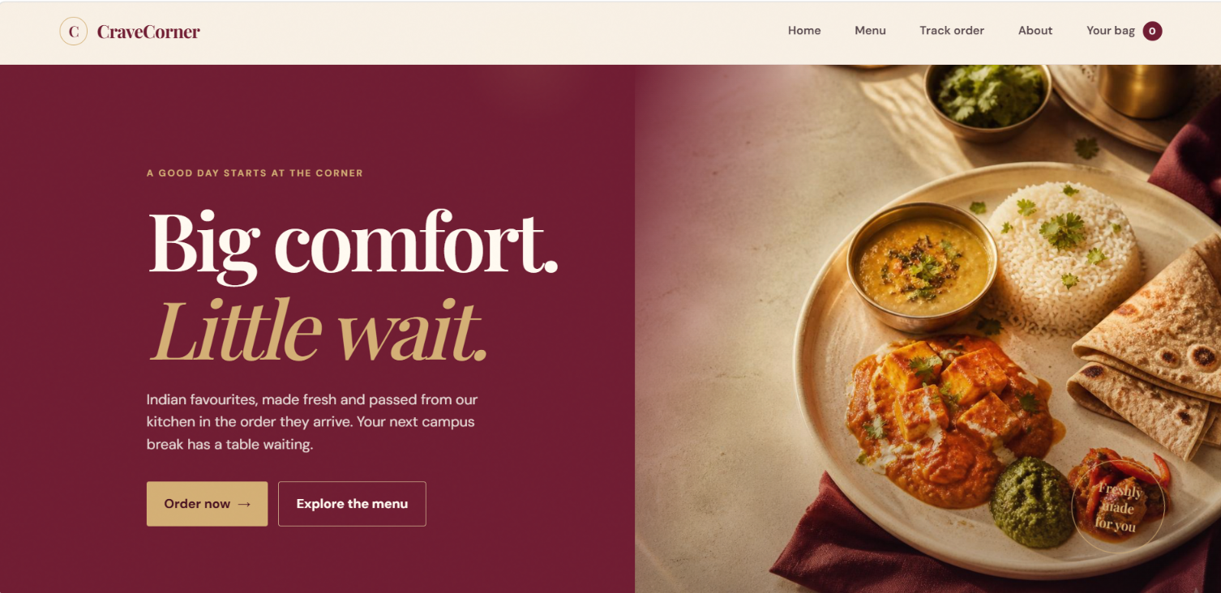

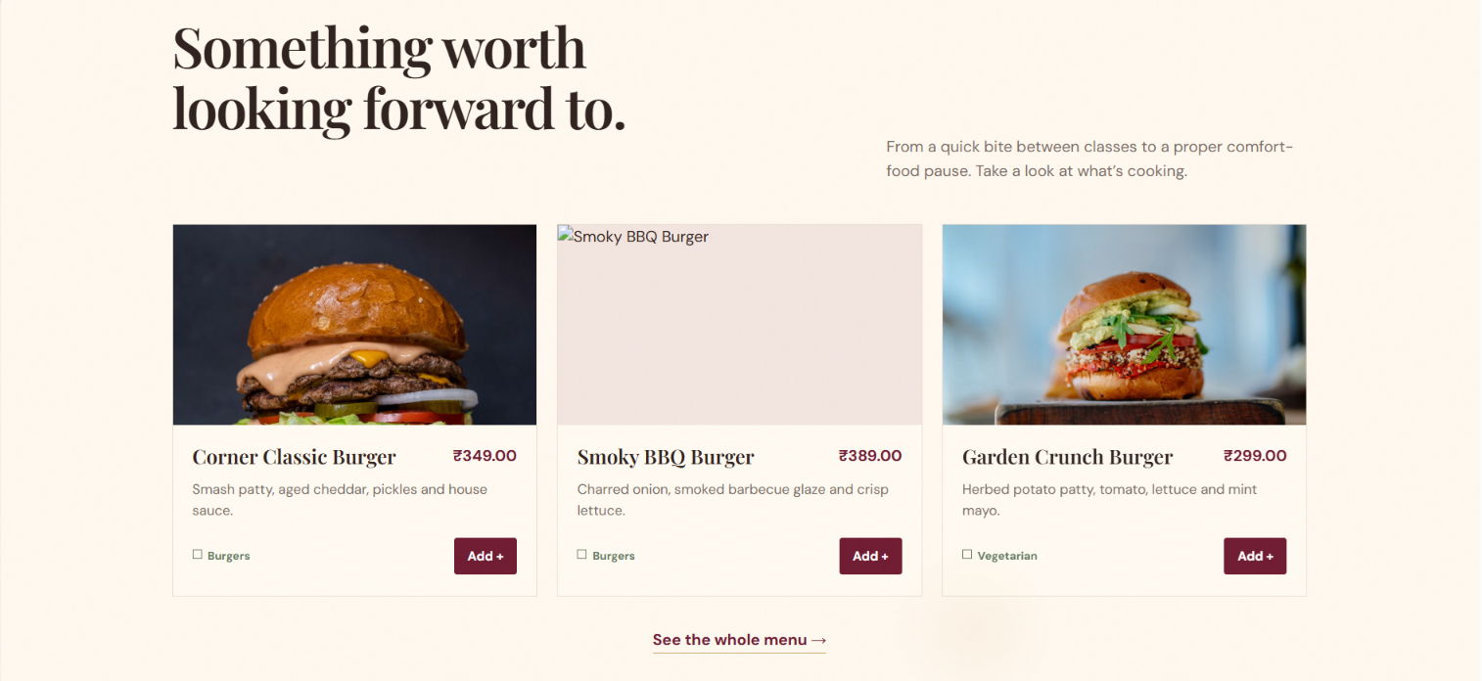

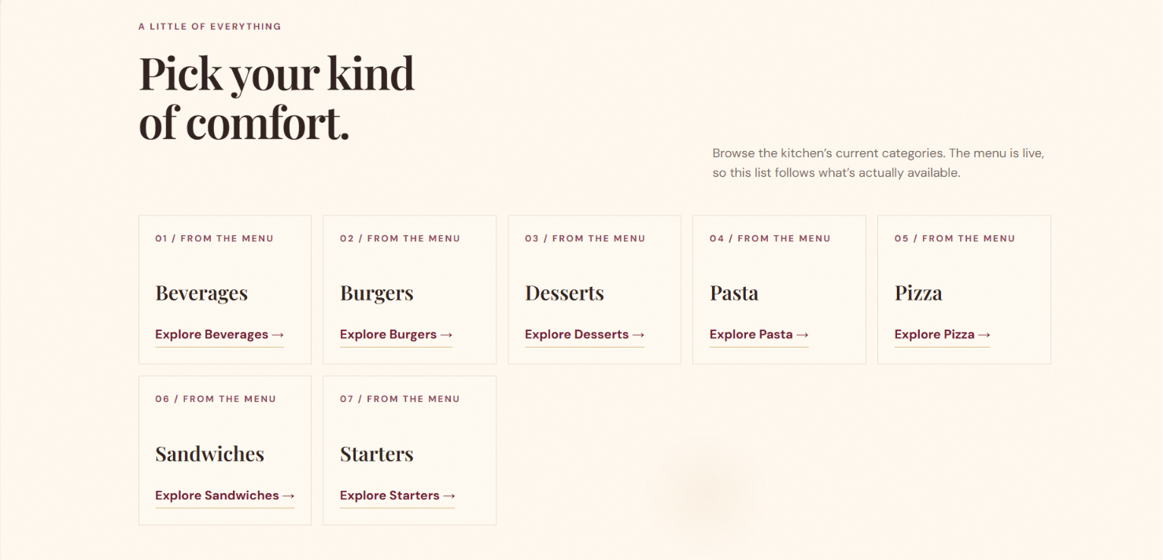

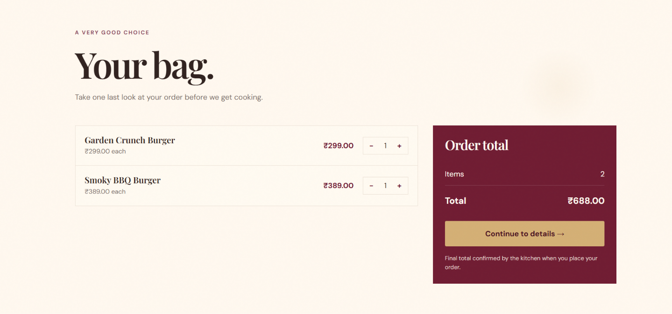

Chapter 8: Analysis

Key Findings
- Queue-Based Order Processing: The Queue data structure follows the First In, First Out (FIFO) principle, ensuring that food orders are processed in the sequence they are received.
- Efficient Order Management: The admin dashboard helps organize incoming orders and manage their preparation and completion status.
- Data Storage: Browser localStorage allows order information to be stored and retrieved without requiring a separate backend or database server.
- User-Friendly Interface: The black-and-orange website design provides a simple interface for customers to place orders and administrators to manage them.
- Practical Application of DSA: The project demonstrates how a fundamental data structure can be applied to a real-world food ordering system.
Quantitative Data
- Order Processing: Orders can be added to the queue and processed in FIFO order.
- Order Status Tracking: Three main statuses are supported: Pending, Preparing, and Completed.
- System Architecture: The website uses three frontend technologies: HTML, CSS, and JavaScript.

- Data Storage: Order information is stored locally in the browser using localStorage.
Note: Actual performance measurements, order counts, and test success rates should be added after testing the implemented website.

Limitations
- No Backend Server: The system does not use a server to manage orders centrally.
- Browser-Dependent Storage: Order data is stored in localStorage and is not automatically shared between different devices or browsers.
- No Online Payment: Payment gateway integration is not included.
- Limited Scalability: The current implementation is suitable for demonstration and small-scale use rather than large restaurants handling many customers simultaneously.
- No Live Delivery Tracking: The system does not provide real-time delivery location updates.
Practical Impact
The project demonstrates a cost-effective way to understand and implement order processing using basic web technologies and data structures. It provides students with practical experience in website development, data management, and FIFO queue operations while illustrating how digital systems can simplify restaurant order handling.

Chapter 9: Inferences

Inferences

Developer Responsibility: Developers must implement proper order validation, secure data handling, and suitable security measures to protect customer information in online food ordering systems.

Data Integrity: The system should ensure that food orders are processed correctly and in the sequence they are received using the FIFO principle.

Application-Level Security: Input validation and sanitization help reduce the risk of malicious input and incorrect order details.

Secure Communication: Using HTTPS in a deployed website helps protect customer information during transmission between the browser and the server.

Limitations of Local Storage: Browser localStorage is suitable for a basic demonstration, but it does not provide centralized storage or strong protection for sensitive information.

System Reliability: Proper testing of order placement, queue operations, and status updates is necessary to ensure consistent system behavior.

Future Improvements: The system can be enhanced with backend integration, database storage, user authentication, secure payment processing, and real-time order tracking.

Chapter 10: Conclusion
Conclusion
This project successfully demonstrated the practical application of the Queue data structure in an Online Food Order Processing System. The website allows customers to place food orders and enables the administrator to manage incoming orders, monitor preparation status, and mark orders as completed.
Critical Takeaway: An efficient order-processing system requires proper queue management, accurate status tracking, and reliable data handling to improve the overall ordering experience.
Future Scope
- Backend Integration: Connect the website to a server and database for centralized order management.
- Online Payments: Integrate secure payment gateways for convenient transactions.
- Real-Time Tracking: Provide live updates on order preparation and delivery.
- User Authentication: Introduce secure customer and administrator login systems.
- Security Enhancements: Implement HTTPS, input validation, and appropriate access controls when deploying the system online.
Final Outcome: The project provides a foundation for understanding how data structures and web technologies can be combined to develop a practical food order management solution. Future enhancements can make it more secure, scalable, and suitable for real-world restaurant operations.

Chapter 11: Suggestions

1. For Developers
- Implement the Queue data structure correctly to ensure FIFO-based order processing.
- Use input validation to prevent incorrect or incomplete food order details.
- Maintain proper order status updates, including Pending, Preparing, and Completed.
- Use secure coding practices and protect customer information when deploying the website online.
- Integrate backend technologies and a database to support centralized order management.
- Test the system regularly to identify errors and improve performance.
2. For Restaurant Administrators
- Monitor incoming orders through the admin dashboard.
- Process orders in the correct sequence to avoid confusion.
- Update order statuses regularly to maintain accurate order information.
- Maintain backups of order data when using a backend database.
- Introduce secure administrator authentication to prevent unauthorized access.
- Consider integrating online payments and delivery tracking in future versions.
3. For Customers
- Enter accurate food selections and order details when placing an order.
- Check the order status to stay informed about preparation progress.
- Use trusted websites when sharing personal or payment information.
- Report incorrect order details or website issues to the administrator.
- Provide feedback to help improve the ordering experience.
4. For Future Development
- Add a backend server using Python Flask or Node.js.
- Integrate a database such as MySQL or PostgreSQL for permanent order storage.
- Implement secure login and role-based access control.
- Add online payment integration and real-time order notifications.
- Optimize queue management to handle larger numbers of orders efficiently.

Chapter 12: Acknowledgments

I would like to express my sincere gratitude to Dr. Dipannita Mondal, HOD of AI & DS, for her valuable guidance and support throughout the development of my mini project, “Online Food Order Processing System.”
I am thankful to my department and faculty members for providing the necessary academic support and resources to complete this project successfully.
I would also like to thank everyone who helped me understand and implement the concepts of Data Structures and Algorithms, particularly the Queue data structure and its First In, First Out (FIFO) principle.
Finally, I am grateful to all those who directly or indirectly contributed to the successful completion of this project. This project has helped me gain practical knowledge of web development, order management, and the real-world application of data structures.

Chapter 13: List of References

- Python Documentation: https://docs.python.org/3/
Used for understanding Python programming concepts and data structures.
- MDN Web Docs – HTML: https://developer.mozilla.org/en-US/docs/Web/HTML
Referred to for developing the structure of the online food ordering website.
- MDN Web Docs – CSS: https://developer.mozilla.org/en-US/docs/Web/CSS
Used for website styling, layout, and user interface design.
- MDN Web Docs – JavaScript: https://developer.mozilla.org/en-US/docs/Web/JavaScript
Referred to for implementing order placement, queue operations, and order status updates.
- MDN Web Docs – Web Storage API: https://developer.mozilla.org/en-US/docs/Web/API/Web_Storage_API
Used to understand browser localStorage for storing order information.
- GeeksforGeeks – Queue Data Structure: https://www.geeksforgeeks.org/queue-data-structure/
Referred to for understanding queue operations and the First In, First Out (FIFO) principle.
- W3Schools – HTML, CSS and JavaScript: https://www.w3schools.com/
Used as a learning resource for basic frontend development concepts.

